**YEAR 12 CHEMISTRY - ATCHE**

**TEST 1**

**Reaction Rates and Equilibrium 2018**

**/ 47**

**-**

**Recommended time: 55 Minutes**

Name: WSHS SOLUTIONS & Marking Guide Lines 2018

Teacher: ___________________________________________

This test is in two parts.

**Part 1:** Multiple choice style test consisting of (12) questions. **(12 Marks )**

Each question is worth 1 mark.

Write your answers in the table provided.

Attempt ALL Questions

**Part 2:** Short and/or Extended Answer questions **(35 Marks)**

Write all answers in the spaces provided.

The marks allocated to each question are shown for each question

Note that questions DO NOT carry an equal number of marks.

Read the questions carefully and keep an eye on the allocated time

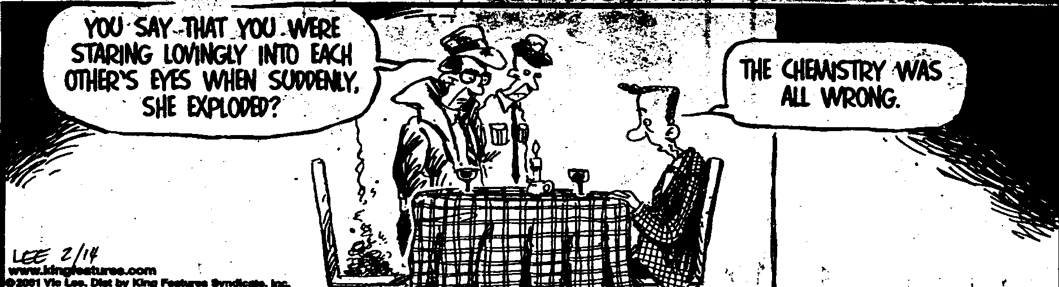

**PART 1: 12 Multiple Choice Questions. Write your answer neatly in the table below. This part is worth 12 marks. *(1 mark / box)***

|  |  |  |  |  |  |  |  |  |  |  |  |
| --- | --- | --- | --- | --- | --- | --- | --- | --- | --- | --- | --- |
| **1** | **2** | **3** | **4** | **5** | **6** | **7** | **8** | **9** | **10** | **11** | **12** |
| **A** | **B** | **C** | **A** | **B** | **C** | **B** | **C or A** | **D** | **D** | **A** | **D** |

**The following information refers to questions 1, 2 and 3.**

Methanol a useful fuel and solvent can be manufactured from hydrogen and carbon monoxide:

**2H2 (g) + CO (g)** ⮀ **CH3OH(g)**

Examine the following potential energy diagram for the above chemical reaction:

Potential energy (kJmol−1)

300.0

200.0

100.0

0.0

Progress of reaction

1 Which one of the following descriptions is **true**?

A. It is an exothermic reaction with the heat of reaction ΔH = - 70 kJ

B. It is an endothermic reaction with the heat of reaction ΔH = + 200 kJ

C. It is an exothermic reaction with the heat of reaction ΔH = - 200 kJ

D. It is an endothermic reaction with the heat of reaction ΔH = + 70 kJ

2 The activation energy for the reaction **CH3OH(g) 2H2(g) + CO(g)** is:

A. + 70 kJ

B. + 220 kJ

C. - 220 kJ

D. + 150 kJ

3 The introduction of a catalyst to the equilibrium system:

**2H2 (g) + CO (g)** ⮀ **CH3OH (g)** would change

A. ΔH only

B. ΔH and the activation energy only

C. the activation energy only

D. the rate of the reverse reaction only

4 Raising the temperature of a reacting system increases the rate of the reaction, but does **not** increase the:

A. activation energy

B. average velocity of the reacting molecules

C. number of successful collisions

D. fraction of the reacting molecules which possess energies greater than the activation energy

5. The following equilibrium is established in a closed system.

**CO2(*g*) + H2O(*l*) ⮀ H2CO3 (*aq*) Δ*H* = –19.4 kJ mol–1**

How can the gas pressure in the system be decreased?

1. Add more CO2(*g*)
2. Add hydroxide ions to the solution
3. Decrease the volume of the container

D. Increase the temperature of the system

6. When silver sulfide is added to water, the following equilibrium is established:

**Ag2S (s) ⮀ 2Ag + (aq) + S 2 – (aq)**

The value of the equilibrium constant in this reaction is very small. What does this suggest?

1. Adding more silver sulfide will increase the amount of ions in solution.
2. Silver sulfide reacts extensively with water.
3. Silver sulfide has a very low solubility.
4. The reaction is endothermic.

7. Consider the following endothermic reaction taking place in a closed vessel

**N2O4 (g)** **⮀ 2 NO2(g)**

Which of the following actions would cause N2O4 to be produced in an increased

amount?

1. Adding a catalyst
2. Decrease the volume
3. Decrease the pressure
4. Increase the temperature

8. The equation describes an equilibrium reaction in a closed system which is

exothermic.

**X(g) + Y(g) ⮀ 4Z(g)**

Under which set of conditions would the highest yield of Z(g) be obtained?

|  |  |
| --- | --- |
| Temperature (°C) | Pressure (kPa) |
| 1. 50 | A,100 |
| 1. 50 | B. 200 |
| 1. 300 | C.100 |
| 1. 300 | D. 200 |

The next two questions, 9 and 10, are about the following reaction:

**4NH3 (g) + 3O2 (g) ⮀ 2N2 (g) + 6H2O (g) ΔH = - 1267 kJ**

Three changes can be made to the reaction:

I. Adding a catalyst.

II. Heating the mixture.

III. Increasing the pressure.

9. Which of the changes will increase the yield of the forward reaction?

1. I only.
2. II only.
3. III only.
4. None of the above.

10. Which of the changes will increase the rate of the forward reaction?

1. I only.
2. I and II only.
3. I and III only.
4. I, II and III.

11. What is the equilibrium constant expression for the dissolving of lead (II) chloride according to the following equation?

**PbCl2 (s) ⮀ Pb 2+ (aq) + 2 Cl –  (aq)**

A. K = [Pb 2+] [Cl – ]2

B. K = [Pb 2+] [2 Cl – ]

C. K = 

D. K = 

12. The following equilibrium mixture is established in a closed container:

**N2O4(g) ⇌ 2NO2(g); ∆*H* = +60 kJ**

N2O4 is a colourless gas but NO2 is a brown gas. If the temperature is decreased and the volume is kept constant, the colour of the equilibrium mixture will:

1. remain the same because both the forward and reverse rates are equally decreased
2. darken because the forward direction is favoured in getting back to equilibrium
3. lighten because the pressure will decrease
4. lighten because the reverse reaction is exothermic

END OF MULTIPLE CHOICE QUESTIONS – Part 1

**PART 2: Section B - Short answers and extended answers (****35 marks total)**

Answer **ALL** the questions in the space provided below. Note that **not** all questions carry equal number of marks.

**Question 13** **(8 marks)**

Chemistry of ocean acidification by increased levels of carbon dioxide is affected

principally by four equilibria. These involve the dissolving of CO2 gas in water, the

reaction of dissolved CO2 with water to form carbonic acid, the dissociation of

carbonic acid into hydrogencarbonate ions, and the dissociation of

hydrogencarbonate ions into hydrogen ions and carbonate ions.

In addition, calcium and carbonate ions present in the water also exist in an equilibrium to form calcium carbonate.

a) Using suitable equations when necessary, explain why an increase in atmospheric

CO2 could lead to fewer hard-shelled organisms in the ocean. (4 marks)

***­Carbon dioxide dissolves in water CO2(g) <-> CO2 (aq)√= 0.5 mark***

***Water then reacts with this aqueous carbon dioxide to form carbonic acid, which then dissociates into hydrogen ions and hydrogencarbonate ions:***

***CO2(aq) + H2O(l) <-> H2CO3(aq)√= 0.5 mark***

***H2CO3(aq) <-> H+ (aq)+ HCO3- (aq) √= 0.5 mark***

***As a result, [H+] increases, the CO32- is a participant in the in two equilibria***

***H+(aq) + CO32-(aq) HCO3-(aq) -------------- Eqn 1√= 0.5 mark***

***Ca 2+ (aq) + CO3 2- (aq)  CaCO3(s)  ----------Eqn 2√= 0.5 mark***

***(i) As [H+] increases the Rate forward (Rf) of Eqn 1 more than the reverse Rxn √= 0.5 mark i.e. [CO32-] is used up at a faster rate and favours the formation of more soluble HCO3-(aq)***

***(ii) As a consequence the Rf  in Eqn 2 decreases and the rate of shell formation CaCO3 √= 0.5 mark decreases and marine invertebrates take longer to mature their shells. √= 0.5 mark***

***(iii) Alternatively, due to a decrease in [CO32-], the rate of reverse reaction in Eqn 2 √= 0.5 mark is faster than the forward reaction and the eq’m shifts to the left (reverse) i.e. thinning of the invertebrates shell or exoskeleton. √= 0.5 mark***

***N.B. only award 1mark total either for (ii) OR (iii) above***

*If a student writes the following equilibrium reaction even though this Rxn does not occur to a large degree.* ***HCO3-(aq ) H+(aq )***  *+* ***CO3 2- (aq) √= 0.5 mar***

b) List three factors that could theoretically be altered to lessen the impact of CO2 on calcium carbonate shelled organisms. (1.5 marks)

***Higher calcium ion concentration √= 0.5 mark Temperature √= 0.5 mark***

***Also accept answers such as plant more trees to soak up CO2 (g) √= 0.5 mark***

***Add CaCO3*** (s) ***Ca (OH) 2  or OH –ions to reduce [ H+ ] ions√= 0.5 mark***

*Any three for 1.5 marks*

c) Name and describe the agreement whereby most of the worlds companies attempted to minimise CO2 production. In your answer, include the year, the number of countries, and two achievements of the agreement. (2.5 marks)

***Kyoto agreement√, in 1997 √when 192 countries√ agreed to cap CO2 emissions. The main achievements were agreement in principle to cap CO2(or √), establishment of a market for CO2 (or √), and development of emission trading schemes (or √). N.B. √ = 0.5 mark***

***Also some students may write the answer as Kyoto was implemented in year 2005 √= 0.5 mark Any 5 points to a maximum of 2.5 marks***

**Question 14. (3marks)**

A student is given the task of reducing the concentration of free metal ions in

various aqueous samples. She is also supplied with ammonia solution. Ammonia is

capable of reacting with metal ions and forming complex ions, this decreases their

concentration in the solution. She adds the same volume of ammonia solution

(an excess) to each test tube initially containing 0.1 mol L–1 solutions of the metal

ions. The information about each reaction is shown below:

|  |  |  |  |
| --- | --- | --- | --- |
| **Test tube** | **Metal ion** | **Equilibrium reaction** | **Equilibrium constant (K)** |
| 1  2  3 | Cd2+  Cu2+  Zn2+ | Cd2+(aq) + 4NH3(aq) ⇌ Cd(NH3)42+(aq)  Cu2+(aq) + 4NH3(aq) ⇌ Cu(NH3)42+(aq)  Zn2+(aq) + 4NH3(aq) ⇌ Zn(NH3)42+(aq) | 1 × 107  1 × 1013  1 × 109 |

*In which of the three test tubes, containing the equilibrium mixtures, will the*

*concentration of the ‘free’ metal ion be the smallest? Explain your reasoning.*

1. ***[Cu 2+] is the lowest in test tube 2******√ = 1 mark***
2. ***This is because K*** *=* ***[ Cu(NH3)4]2+****­ K increases as [ Cu 2+] decreases*

*---------------------* ***√ = 1 mark***

***[ Cu 2+] [ NH3]4***

1. ***K expression is identical for each of the free metal ion and stoichiometrically identical***
2. ***[ Cu 2+] must be the lowest since [ NH3] is identical in all test tubes.***

***√ = 1 mark***

* *Any 3 for three marks.*

**Question 15 (3 marks)**

Write the equilibrium constant (K) expression for the following reactions

a) Fe(NO3)3(s) + 6H2O(l) ⇌ [Fe(H2O)6]3+(aq) + 3NO3– (aq) ΔH = + 45 kJ mol-1

***K = [ Fe (H2O)6 (aq) ]3+ [ NO3-1 (aq)] 3 √ = 1 mark or zero***

b)The reaction in (a) above is carried out at 25 °C. What will happen to the

equilibrium constant (K) value if the temperature is increased to 75°C.

***As temp increases K value will increase because the reaction favours an increase in the products by shifting the eq’m position to the RHS***

***√ = 1 mark***

c) 2Hg(g) + O2(g) ⇌ 2HgO(s)

***1***

***K = -------------------------- √ = 1 mark or zero***

***[ Hg (g) ]2 [ O2(g) ]***

**Question 16 (5 marks)**

Ethene (C2H4) may be produced from ethane (C2H6) according to the following reversible reaction:

**C2H6 (g) ⮀ C2H4 (g) + H2 (g) ΔH = + 120 kJ mol – 1**

**1mole 2 moles**

(a) State three conditions that increase the rate of the forward reaction.

1. ***High Temperature or Increased Temp √ = 1 mark***
2. ***Add a suitable catalyst √ = 1 mark***
3. ***High Pressure or Increased Pressure √ = 1 mark***

(b) State two conditions which would increase equilibrium yield (favour products).

1. ***High Temperature or Increased Temp √ = 1 mark***

1. ***Reduce Pressure or increase volume √ = 1 mark***

**Question 17 (4 Marks)**

The diagram below shows Maxwell – Boltzmann distribution for a sample of a gas at fixed temperature. Ea is the activation energy for the decomposition of this gas.

*T2 Curve displaced to the right.*

*Lines of curves should not cross or touch. √ = 1 mark*

*Area under T2 curve > T1 curve √ = 0.5 mk Curve for T2 starts at origin. √ = 0.5 mk*

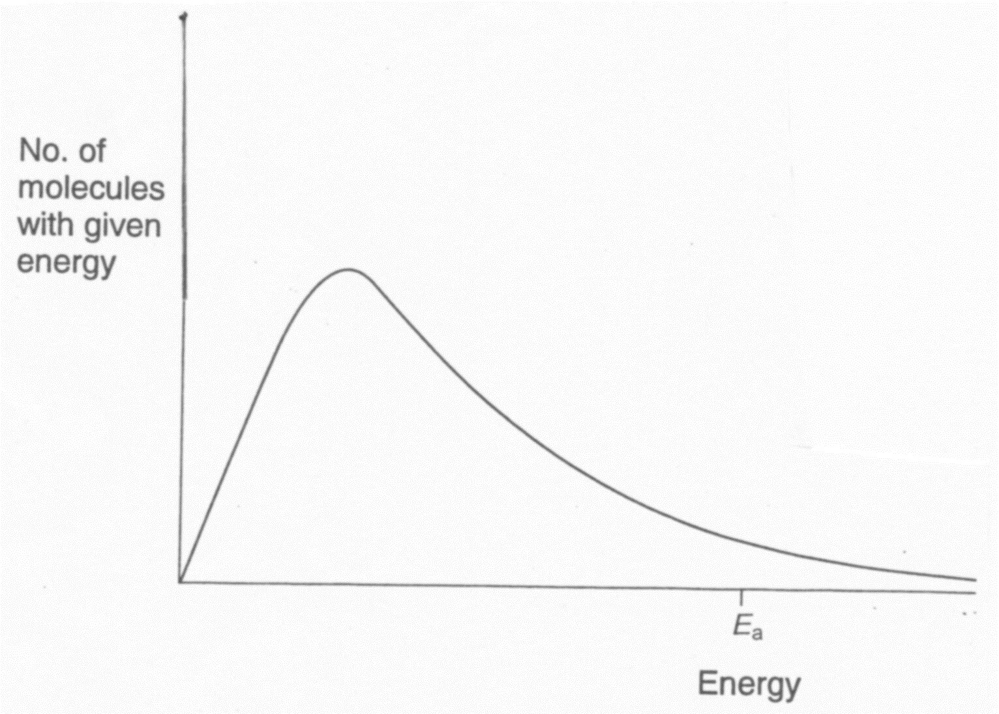

T1

Low Temp

20(a) On this diagram, sketch neatly the distribution for the same sample of gas at

high temperatures (T2) showing why an increase in temperature increases the rate of

a chemical reaction. (see diagram above)

(2 marks)

20 (b) With reference to the Maxwell – Boltzmann distribution, **explain** why an

increase in temperature from T1 to T2 increases the rate of a chemical reaction. (2 marks)

***Increased proportion or No. of molecules with Ek > Ea √ = 0.5 mark***

***As Temp increases, more gas molecules on average, have greater No. of molecules with sufficient energy to react via successful collisions to overcome the Ea.******√*** *= 1* ***mark***

***Increased frequency of fruitful collisions leads to an increase in the rate of chemical reactions.***  *√* ***= 0.5 mark***

**Question 18 (3 Marks)**

The following equilibrium is being investigated:

**2 ZnS (s) + 3 O2 (g) ⮀ 2 ZnO (s) + 2 SO2 (g) ΔH = - 879 kJ**

Three identical sealed boxes are set up, each containing the equilibrium mixture. Each

of the boxes is treated as described below, and time is allowed for a new equilibrium

to be established. In each case describe the change between the original equilibrium

and the new equilibrium. ***√ = 0.5 mark/box***

|  |  |  |
| --- | --- | --- |
| Treatment | What happens to the rate of forward reaction?  Write ‘increases’, ‘decreases’ or ‘no change’ | What happens to the equilibrium position.  Write ‘move to the right’, ‘move to the left’ or ‘no change’ |
| A small amount of O2 (g) is added. | ***Reaction Increases***  ***√ = 0.5 mark*** | ***Moves to the right***  ***√ = 0.5 mark*** |
| Ne (g) is pumped in, increasing the pressure of the system (no volume change). | ***No Change***    ***√ = 0.5 mark*** | ***No change***  ***√ = 0.5 mark*** |
| The reaction vessel is heated. | ***Increases***  ***√ = 0.5 mark*** | ***Moves to the left***  ***√ = 0.5 mark*** |

**Question 19**  **(9 Marks)**

Consider the equilibrium shown below by the following equation

**C(s) + H2O(g) ⇄ CO(g) + H2(g)**

The graph below represents the concentration of three species for the first 10

minutes of reaction, and afterwards when a change is made to the system at the

10 minute mark. The reaction is exothermic.

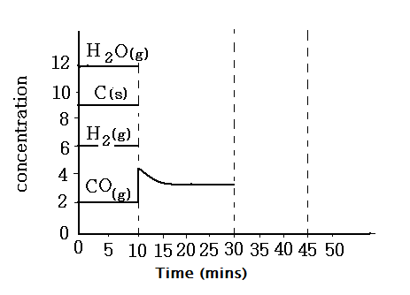

19. At the 10 minute mark, more CO gas is pumped into the system.

(a) Show on the graph a neat representation of the expected changes to the

concentration of the other two substances during the time 10 to 30 minutes. (3 marks)

19 (b) Use the collision theory to **explain** the changes of H2O, CO and

H2 between 10 and 30 minutes. (3 marks)

***C(s) + H2O(g) ⇄ CO(g) + H2(g)***

***At 10 minutes the [CO(g) ] is increased (doubled) which means there are more molecule per unit volume. √ = 0.5 mark***

***The number of increased frequency of successful collisions between CO and H2 increase the reverse reaction rate to overcome Ea whilst the forward rate remains the same.***

***√ = 1 mark***

***The products are converted to reactants at a faster rate Rb > Rf √ = 1 mark***

***As a consequence [ H2O] increases whilst [ CO] and [H2(g)] will decrease until***

***Rf = Rb and eq’m is re-established. √ = 0.5 mark***

19 (c) At 30 minutes the reaction vessel is warmed up by increasing the temperature.

Neatly draw the concentrations of each species for the next 15 minutes. The

equilibrium is achieved at 45 minutes (3 marks)

***See mark allocations on the drawn graph.***

**END OF EQUILIBRIUM TEST 1 2018. GO BACK AND RE- CHECK YOUR ANSWERS**